Consider the Turing Machine shown in Figure 1:

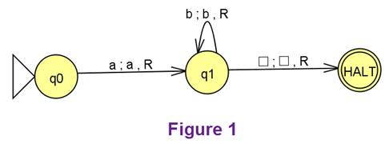

Does it accept the string abbb? **yes**

Does it accept the string a? **yes**

Does it accept the string aba? **no**

Does it accept the string accc? **no**

Consider the Turing Machine shown in Figure 2:

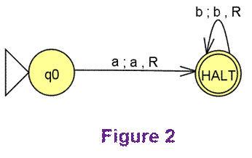

Does it accept the string abbb? **no**

Does it accept the string a? **yes**

Does it accept the string aba? **no**

Does it accept the string accc? **no**

Consider the Turing Machine shown in Figure 3:

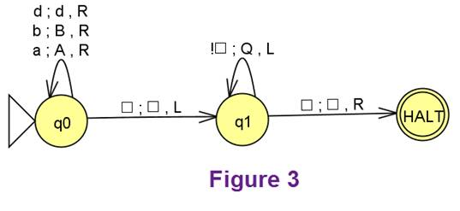

Does it accept the string accc? **no**

Does it accept the string ^? **yes**

Does it accept the string dab? **yes**

Suppose you start with the string abbd written on the tape. When the machine stops,

What is written on the tape? **QQQQ**

Where is the tape head pointing? **At the first letter that is written on the tape**

Which of these statements about the pumping lemma for context-free languages is true? **The pumping lemma for context-free languages tells us some facts about infinite (but not finite) context-free languages.**

Which of the following is an American Holiday that occurs in November? **Thanksgiving**

Which of the following statements can we say is true after understanding the halting problem? **That there exists at least one program that cannot be written using any kind of Turing Machine.**